Задание № 1 «Ось»
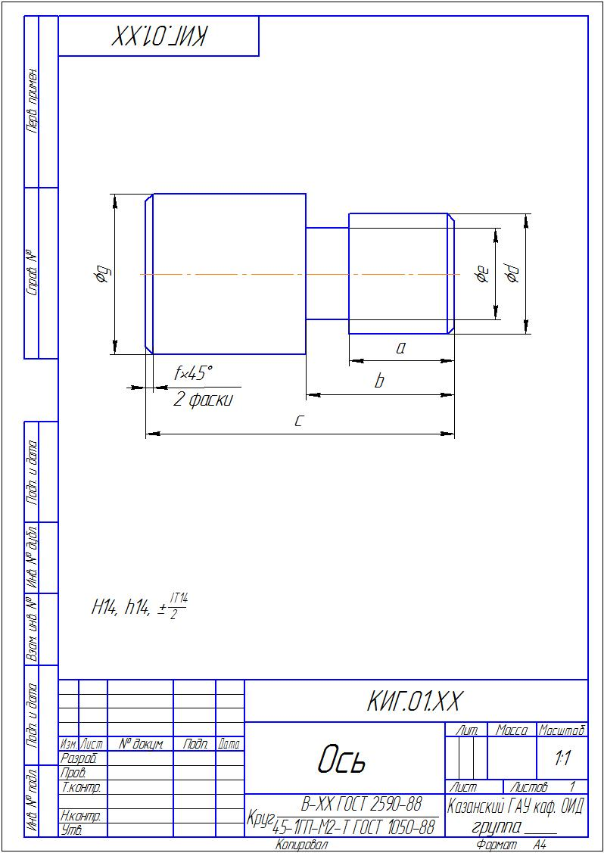
В обозначении КИГ.01.ХХ (ХХ - номер варианта)
Варианты к заданию № 1
«Ось»
№ вар. | а | b | с | d | е | f | g
0 | 51 | 63 | 118 | 49 | 39 | 1 | 67
1 | 31 | 45 | 92 | 45 | 32 | 1 | 55
2 | 41 | 56 | 117 | 43 | 35 | 1 | 57
3 | 47 | 59 | 118 | 41 | 31 | 4 | 57
4 | 45 | 57 | 116 | 47 | 34 | 1 | 62
5 | 43 | 52 | 95 | 39 | 31 | 1 | 55
6 | 35 | 47 | 98 | 42 | 29 | 3 | 54
7 | 45 | 56 | 113 | 41 | 33 | 4 | 64
8 | 45 | 56 | 112 | 51 | 40 | 4 | 66
9 | 45 | 58 | 114 | 42 | 33 | 2 | 56
10 | 31 | 45 | 87 | 39 | 31 | 2 | 61
11 | 34 | 48 | 86 | 43 | 34 | 4 | 67
12 | 37 | 49 | 103 | 39 | 28 | 4 | 53
13 | 46 | 56 | 106 | 46 | 38 | 2 | 65
14 | 41 | 54 | 101 | 41 | 29 | 2 | 55
15 | 49 | 60 | 117 | 42 | 34 | 2 | 64
16 | 33 | 47 | 96 | 40 | 29 | 1 | 57
17 | 38 | 48 | 105 | 50 | 38 | 1 | 66
18 | 40 | 53 | 107 | 42 | 31 | 4 | 62
19 | 31 | 42 | 93 | 43 | 35 | 2 | 59
20 | 30 | 41 | 89 | 48 | 35 | 2 | 55
21 | 43 | 56 | 116 | 41 | 33 | 2 | 56
22 | 37 | 50 | 104 | 40 | 31 | 4 | 62
23 | 34 | 41 | 89 | 41 | 32 | 2 | 57
24 | 33 | 39 | 86 | 46 | 36 | 1 | 59
25 | 44 | 60 | 110 | 47 | 34 | 2 | 60
26 | 38 | 52 | 102 | 37 | 27 | 4 | 53
27 | 35 | 50 | 94 | 43 | 31 | 2 | 53
28 | 39 | 54 | 112 | 40 | 29 | 2 | 53
29 | 37 | 46 | 93 | 43 | 33 | 2 | 57
30 | 41 | 54 | 108 | 43 | 32 | 4 | 63
31 | 47 | 57 | 107 | 47 | 39 | 2 | 66

