Задание № 2 «Ролик»
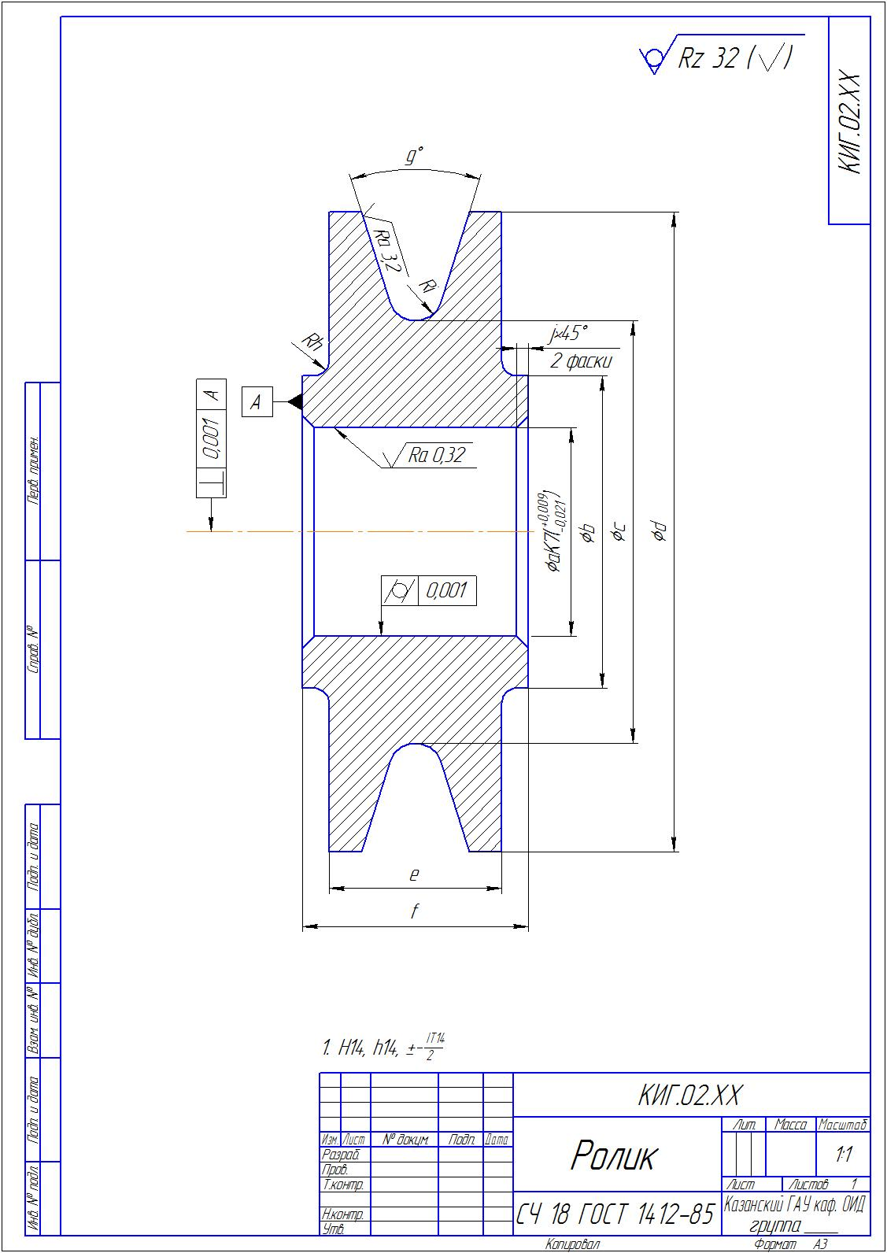
В обозначении КИГ.02.ХХ (ХХ - номер варианта)
Варианты к заданию № 2
«Ролик»
№ вар. | а | b | с | d | е | f | g | h | i | j
0 | 71 | 88 | 139 | 233 | 70 | 83 | 34 | 4 | 9 | 4
1 | 64 | 81 | 132 | 216 | 71 | 85 | 33 | 6 | 8 | 2
2 | 58 | 75 | 126 | 218 | 70 | 85 | 32 | 6 | 10 | 4
3 | 56 | 73 | 124 | 219 | 76 | 90 | 34 | 6 | 10 | 4
4 | 62 | 80 | 134 | 222 | 70 | 85 | 33 | 6 | 10 | 4
5 | 69 | 87 | 141 | 224 | 75 | 90 | 32 | 5 | 8 | 2
6 | 74 | 90 | 138 | 229 | 76 | 90 | 34 | 5 | 9 | 4
7 | 65 | 83 | 137 | 226 | 75 | 88 | 34 | 4 | 9 | 4
8 | 70 | 87 | 138 | 228 | 73 | 86 | 34 | 4 | 9 | 4
9 | 70 | 88 | 142 | 210 | 73 | 89 | 32 | 5 | 9 | 4
10 | 64 | 82 | 136 | 211 | 73 | 87 | 31 | 5 | 8 | 2
11 | 71 | 87 | 135 | 212 | 70 | 84 | 30 | 4 | 10 | 4
12 | 69 | 85 | 133 | 231 | 71 | 85 | 34 | 4 | 8 | 2
13 | 61 | 78 | 129 | 230 | 71 | 85 | 32 | 6 | 7 | 2,5
14 | 71 | 88 | 139 | 226 | 75 | 91 | 33 | 4 | 10 | 4
15 | 55 | 71 | 119 | 214 | 76 | 89 | 31 | 6 | 10 | 4
16 | 67 | 85 | 139 | 231 | 71 | 87 | 30 | 4 | 7 | 2,5
17 | 68 | 85 | 136 | 234 | 70 | 86 | 34 | 5 | 9 | 4
18 | 64 | 82 | 136 | 213 | 73 | 88 | 31 | 4 | 10 | 4
19 | 56 | 73 | 124 | 227 | 75 | 89 | 30 | 6 | 9 | 4
20 | 74 | 90 | 138 | 230 | 72 | 86 | 30 | 4 | 8 | 2
21 | 66 | 82 | 130 | 235 | 73 | 87 | 33 | 6 | 9 | 4
22 | 58 | 74 | 122 | 213 | 76 | 90 | 33 | 4 | 10 | 4
23 | 73 | 90 | 141 | 220 | 76 | 91 | 31 | 4 | 8 | 2
24 | 68 | 84 | 132 | 218 | 72 | 87 | 32 | 5 | 10 | 4
25 | 68 | 84 | 132 | 213 | 70 | 85 | 33 | 6 | 8 | 2
26 | 67 | 84 | 135 | 225 | 75 | 89 | 33 | 6 | 9 | 4
27 | 62 | 80 | 134 | 222 | 73 | 89 | 31 | 6 | 7 | 2,5
28 | 60 | 78 | 132 | 225 | 75 | 89 | 34 | 5 | 7 | 2,5
29 | 61 | 77 | 125 | 227 | 72 | 86 | 30 | 6 | 8 | 2
30 | 61 | 79 | 133 | 222 | 71 | 84 | 33 | 5 | 8 | 2
31 | 65 | 83 | 137 | 222 | 71 | 86 | 34 | 5 | 8 | 2

